Policy #: 4.13
Original Policy Number: 4.13
Original Policy Created: 4-18
Date Reviewed: 4-18
Approved: 4-18

Chapter Affiliation Agreement

This Affiliation Agreement (the “Agreement”), is made this 5 day of December, 2018, by and between the International Association of Forensic Nurses (“IAFN”) a 501 (c) (6) nonprofit corporation, with its principal place of business at 6755 Business Parkway, Ste 303, Elkridge, Maryland 21075 and the Chapter(“Chapter”), an affiliate of IAFN, with its principal place of business at 6755 Business Parkway, Suite 303, Elkridge, MD 21075..

Now therefore, in consideration of the premises set forth above and the promises set forth below, the sufficiency and receipt of which are hereby acknowledged, the parties hereby agree as follows:

Definitions

- Activities: A meeting, educational program or event that is organized and/or promoted by a chapter.

- Chapter: A local subsidiary branch of the Parent Association, the International Association of Forensic Nurses, that shall fall under the Parent Association’s 501c6 group tax exemption status.

- Chief Executive Officer: The person responsible for the overall administration of the International Association of Forensic Nurses.

- Chief Financial Officer: The person responsible for financial management of all chapter bank accounts.

- IAFN Home Office: The primary location of the Parent Association which serves as the administrative center for the International Association of Forensic Nurses.

- Intellectual Property: An intangible asset that consists of human knowledge and ideas. Some examples are published standards of practice, education guidelines, copyrights, and trademarks.

- Trade Secret: According to the Uniform Trade Secrets Act, it is information, including a formula, pattern, compilation, program device, method, technique, or process, that: (i) derives independent economic value, actual or potential, from not being generally known to, and not being readily ascertainable by proper means by, other persons who can obtain economic value from its disclosure or use, and (ii) is the subject of efforts that are reasonable under the circumstances to maintain its secrecy.

Grant of Charter to Chapter

- Charter. IAFN, through Board approval, hereby grants to Chapter a non-exclusive charter to be a chapter of IAFN. In accordance therewith, Chapter is authorized to use the name “International Association of Forensic Nurses”, acronym “IAFN”, and logo of IAFN in connection with Chapter’s name, acronym and logo, with the authority to use such marks in connection with Chapter’s activities authorized under this Agreement, subject to the terms and conditions of this Agreement and any written guidelines attached hereto, otherwise incorporated herein, or subsequently provided to Chapter by IAFN.

- Term and Termination. The term of this Agreement shall commence on the effective date set forth above and shall continue until December 31st of the same year. At that time, the Agreement will be up for renewal. Renewals will occur on an annual basis. The IAFN home office and/ or Board of Directors reserves the right to terminate a chapter’s charter at any time with written electronic 30- day notice to the current chapter members. The chapter board members may request in writing to the Chapter staff liaison, Chief Financial Director and the CEO a request to close the chapter. The request must state the reason for the closure and notice must be made to all current chapter members.
- Authorized Activities. All activities of the Chapter must be consistent with the mission and purposes of the IAFN.

Membership

Members of the Chapter must also be current members of IAFN. The terms and conditions of membership in IAFN shall be determined exclusively by IAFN. Further terms and conditions of membership in the Chapter shall be determined exclusively by the Chapter and shall be set forth in Chapter Bylaws. All new and renewal Chapter and IAFN membership dues shall be collected directly from members by IAFN Home Office. IAFN shall then remit Chapter dues to the Chapter on a quarterly basis. If a new chapter member is already an IAFN member, that member may pay their chapter dues to IAFN Home Office or directly to the chapter. If paid directly to the chapter, chapter must notify IAFN Home Office within 30 days.

Any individual interested in joining a Chapter, but is not a current IAFN member, should be directed to the IAFN Home Office.

Chapter Member Termination. Causes and procedures for termination of a chapter membership shall be the same as outlined in the IAFN bylaws for members.

Member Chapter Dues. In addition to dues paid to the home office, dues for a one-year Regular Chapter Membership shall be $30 per year, or $78 for 3 years, or $120 for 5 years.

Dues for a one-year Associate Chapter Membership shall be $25 per year, $65 for three years, or $100 for 5 years.

Dues for a two-year Student Chapter Membership shall be $25 a year and no discounts will be offered beyond the two-years.

No lifetime memberships will be offered for Chapter Membership.

Obligations of IAFN

IAFN’s obligations under this Agreement shall include the following:

- Provide New Chapter Board Member orientation.
- Provide link on website to Chapter Page and/or Chapter’s website.
- Provide free event listing on IAFN’s website.
- Provide, on a regular basis, a list of members in the Chapter area for recruitment purposes.
- Provide administrative services by collecting chapter dues with IAFN dues and process an ACH transaction back to the Chapter on a quarter basis.
- Provide chapter with physical mailing address of the IAFN Home Office, 6755 Business Parkway, Suite 303, Elkridge, MD 21075.Chapter will use the IAFN office as their physical mailing address.
- In the event the chapter receives mail the staff of IAFN will open, scan, and electronically send all corresponding documents to the chapter president and treasurer within one week of date of receipt.
- The Chief Financial Officer will establish a chapter bank account and on-line banking system and serve as the primary account holder with access granted to the designated chapter representative(s).

- Provide an email account for each chapter. Providing the username and password to the secretary.

Obligations of the Chapter

Chapter obligations under this Agreement shall include the following:

- Chapter Name. IAFN must be incorporated within the name of the Chapter.
- Chapter must obtain its own Federal Employment Identification Number

- Chapters must use the IAFN home office as their resident agent mailing address.

- Chapters must have an IAFN designated email account(s) address to be checked regularly by the chapter’s designated Board member. Emails to the chapter members must be sent from the IAFN chapter email address. IAFN Home Office staff liaison will establish the email address and provide the secretary of each chapter the username and password for their chapter designated email account. Passwords should not be changed without notification in writing to the home office.

- Chapters must use the same fiscal year as IAFN (January 1 to December 31). Chapter shall renew their charter every year which shall be due by March 1st of the following year. Chapters must submit annual activity reports to the IAFN Home Office due March 1st of each year. Activity reports shall include changes in officers, all program dates and sites, and such other data as required. Reports must be clear and legible, preferable typewritten or electronically.

- Chapters must maintain at least 15 members with continued annual growth.

- The Chapter’s membership list shall not be sold or shared with any third parties. Third parties wishing to utilize the mailing list should contact IAFN for information on list availability.

- Chapter Logo. The IAFN Home Office will provide the Chapter with a logo in various electronic formats.

- Government Affairs. Chapters shall not participate in or contribute to any political campaign on behalf of or in opposition to any candidate for public office. See IAFN Government Relations Policy for further clarification.

- Tax Status. A Chapter is exempt from federal income tax pursuant to the IAFN group exemption; however, tax forms 990 or 990 EZ must be filed if gross receipts for the year (Jan 1-Dec 31) are over $50,000. The E-990 electronic postcard is filed if the yearly gross receipts are under $50,000. A copy of Chapter’s tax returns or notice must be sent to the IAFN Home Office annually with renewal. The chapter will be included under IAFN’s umbrella tax exempt status as long as the chapter maintains the terms of this agreement. Chapters are not allowed to apply for their own tax-exempt status at this time.

- Bylaws. Chapters shall adopt at least the minimum required Bylaws approved by the IAFN Board of Directors (See template in Exhibit A). Chapters shall review them at least every three (3) years. Bylaws and any changes shall be approved by the IAFN CEO.

- Chapter Bylaws. Chapter shall have as its purposes those set forth in the Template Bylaws attached hereto, shall conduct its activities at all times in strict accordance with such Bylaws, and shall comply at all times with all of the requirements as set forth in IAFN’s Bylaws and all other chapter-related policies, procedures, handbooks, or other written guidance heretofore or hereafter promulgated by IAFN. If chapters act outside the Chapter bylaws, IAFN bylaws, or act in a manner that is tortuous, a violation of law or public policy, IAFN is not required to indemnify the chapter.

1. A copy of the Chapter Bylaws shall be kept on file at all times with the IAFN Home Office.

- Bank Account. Chapter must obtain its own Federal Employment Identification Number and maintain its IAFN issued bank account.

  - Chapter treasurer will notify the IAFN Chief Financial Officer within 30 days of election to begin the process of becoming an approved signor on the chapter bank account.
  - Chapters will maintain only one primary operating bank account in accordance with the IAFN chapter Policy.
  - All Chapter funds must be used for chapter related expenses. Funds used for non-chapter related expenses are subject to repayment with interest and qualify for the revocation of the chapter charter

- Recordkeeping, Reporting and Inspection. Chapter shall maintain reasonable records related to all of its programs, activities and operations. Chapter shall submit regular written reports, as requested by IAFN, summarizing its programs, activities and operations, including but not limited to budget, financial statements, and bank account statements. Upon the written request of IAFN, and at IAFN’s expense, Chapter shall permit IAFN or a designated agent to review appropriate records of Chapter pertaining to its programs, activities and operations. Alternatively, Chapter shall send to IAFN copies of such records within 10 business days. IAFN can audit or review expenses at any time.

  - The Chapter shall keep correct and complete books and records of its accounts, meetings, proceedings, and membership and all valuable papers and documents of the Chapter in accordance with the chapter financial policy.

  - The historical documents of the chapter, including IAFN Affiliation Agreement, Chapter Bylaws with all amendments, Incorporation papers, and meeting minutes, shall be contained together and shall reside with the current Chapter Chair and at the home office.

  - A minimum of 4 meetings must be held and documented annually through recording of minutes.

- Events. Chapter must hold at least one educational training per year (i.e. in person, webinar, etc). Chapter must provide a list of all events including dates, locations and a copy of promotional materials to IAFN’s Home Office before event takes place.

- Annual Conference. Chapter shall arrange for Chapter representation at a minimum of one IAFN Parent Association meeting per year.

- Website. Chapters may create an individual web site which may be linked to the IAFN Web site. Chapters may also request a Microsite through the IAFN Home office which has an additional annual fee.

- Chapter Documentation. All required documentation, as stated in the
Documentation Checklist and in accordance with the IAFN Chapter Financial Policy must be provided and delivered to the IAFN Home Office annually.

- Indemnification. Chapter shall indemnify, save and hold harmless IAFN, officers, directors, employees, members, and partners from and against any and all claims, actions, suits, demands, losses, damages, judgments, settlements, costs and expenses (including reasonable attorneys’ fees and expenses), and liabilities of every kind and character whatsoever (a “Claim”), which may arise by reason of (i) any act or omission by Chapter, officers, directors, members or partners, or (ii)the inaccuracy of breach of any of the covenants, representations and warranties made by Chapter in this Agreement. This indemnity shall require the Chapter to provide payment to IAFN of costs and expenses as they occur. Chapter shall promptly notify IAFN upon receipt of any Claim and shall grant to IAFN the sole conduct of the defense to any Claim. The provision of this Section shall survive any revocation, surrender or other termination of this Agreement. The chapter will be responsible for all legal fees incurred by the IAFN.

- Legal Action. Chapter must notify the IAFN home office should the chapter be involved in any kind of legal action or have the need to hire an attorney. IAFN Home Office will be directly and actively involved in any such scenario.

- Confidential Information.

  - Intellectual Property and Trade Secrets

    - The Intellectual Property and Trade Secrets is and shall remain at all times the sole and exclusive property of IAFN. The Intellectual Property and Trade Secrets may be used by the Chapter of IAFN if and only if such use is made pursuant to the terms and conditions of this limited and revocable license. Any failure by Chapter to comply with the terms and conditions contained herein, whether willful or negligent, may result in the immediate suspension or revocation of this Agreement by IAFN. Failure to comply, whether willful or negligent, also may result in the suspension or revocation of the charter of the Chapter by IAFN. The interpretation and enforcement (or lack thereof) of these terms and conditions, and compliance therewith, shall be made by IAFN in its sole discretion.

    - Chapters may not alter or republish as their own any of IAFN’s Intellectual Property.

    - Intellectual Property must be used by the Chapter in a professional manner and solely for official Chapter related purposes. Chapter shall not permit any third party to use the Intellectual Property without IAFN’s prior written approval.

    - In any authorized use by Chapter of the Intellectual Property, Chapter shall ensure that the applicable trademark and copyright notices are used pursuant to the requirements of United States law and any other guidelines that IAFN may prescribe.

    - IAFN may request the signing of Copyright Assignment or other appropriate documents before the use of Intellectual Property.

    - IAFN reserves the right to request samples of use of the Intellectual Property from which it may determine compliance with these terms and conditions. IAFN also reserves the right to prohibit use of any of the Intellectual Property, as well as to impose other sanctions, if it determines, in its sole discretion, that Chapter’s usage thereof is not in strict accordance with the terms and condition of this limited and revocable Agreement.

  - Proprietary Information

      - IAFN Members may have access to confidential or proprietary information as part of membership, never to be disclosed to a third party without IAFN’s direct and express approval.

      - Insofar as IAFN has published its own documents (ie. Standards of Practice, Education Guidelines, etc.), the Chapter shall not publish its own or similar documents.

Approval Process

- New Chapters shall submit all formation documentation to the home office electronically. This includes

  - Letter of intent to the IAFN Board to create a chapter, including chapter name
  - Chapter Bylaws signed
  - Chapter Affiliation Agreement signed
  - Chapter Officer List
  - Financial Policy signed
  - Confirmation letter of an Employer Identification Number (EIN)
  - $75 application fee

- All applications for chapter status shall be made in writing on the forms prepared by the Association and shall be accompanied by the $75 application fee.

- Only after all materials have been submitted, the application will be forwarded to the IAFN Board of Directors for approval of chapter status.

- Once chapter status has been approved, the Chief Financial Officer will establish a bank account in the chapter name.

Renewal Process

- All chapters are required to renew on an annual basis by submitting to the IAFN Home Office proper documentation, which can be found on the IAFN website.

- If the chapter fails to submit all proper documentation by deadline of March 1st, the
“Liquidation of Assets” guidelines found under Section VIII. D. will apply.

- IAFN CEO will have the authority to approve chapter renewals.

Revocation or Surrender of Charter

- Revocation. The charter granted by IAFN to the Chapter hereunder shall remain in full force and effect until all annual renewal paperwork is due (March 1st), following
the date of the agreement, unless and until revoked by IAFN or surrendered by the Chapter in accordance with the provisions of this Agreement. IAFN, through its Board of Directors, shall have the authority to revoke the charter of the Chapter. Any decision by IAFN to revoke the Chapter’s charter shall be initiated by sending notice to the Chapter specifying the grounds upon which the revocation is based. In the event that IAFN determines, in its sole discretion, that the Chapter has not corrected the condition leading to IAFN’s decision to revoke the Chapter’s charter, IAFN shall so notify the Chapter in writing of final date of revocation. Revocation of Charter will also occur if required, annual documentation has not been provided within 60 days following the renewal date or chapter obligation(s) have not been met.

- Surrender. The Chapter may surrender its charter by delivering to IAFN written notice of its intention to do so no less than 30 days prior to the effective date of such surrender.

- Chapter Property. All books, records, files, photographs or other chapter materials and assets shall be packaged and shipped to the IAFN Home Office within 30 days of revocation or surrender final date.

- Liquidation of Assets. The home office shall use the assets of the chapter to pay any outstanding debts or bills. Remaining assets will be liquidated to cash and held in escrow for a period of no more than one year from the date of revocation. Should members in that same geographic area be approved to form a new chapter, the funds may be requested for distribution to the newly formed chapter. If no request has been made after one year from the date of revocation, remaining funds shall be earmarked for purpose of providing education to IAFN Members. The IAFN Home Office will maintain any chapter records for a period of seven years. Under both Revocation and Surrender, all assets, including the balance of the bank account must be turned in to IAFN’s Home Office.

  - Thirty (30) days following charter renewal date, a late reminder will be sent to the chapter President.
  - Sixty (60) days following charter renewal date, the IAFN Home Office will call the Chapter President as a final reminder.
  - Ninety (90) days following the date the charter was due to renew, the chapter will be disbanded immediately.

Arbitration

Any and all disputes arising under this Agreement shall be subject to mandatory and binding arbitration. Said arbitration shall take place in the State of Maryland. Neither party shall have any right to bring an action relating to this Agreement in a court of law, except insofar as to either enforce or appeal the results of any such arbitration. In any such arbitration, and subsequent court action, the prevailing party shall be entitled to collect its fees and costs associated therewith from the non-prevailing party.

IN WITNESS WHEREOF, the parties hereto have caused duplicate originals of this Agreement to be executed by their respective duly authorized representatives as of the date and year stated above.

International Association of Forensic Nurses Chapter: Pennsylvania

Signature: 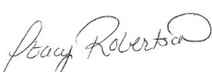 Signature: 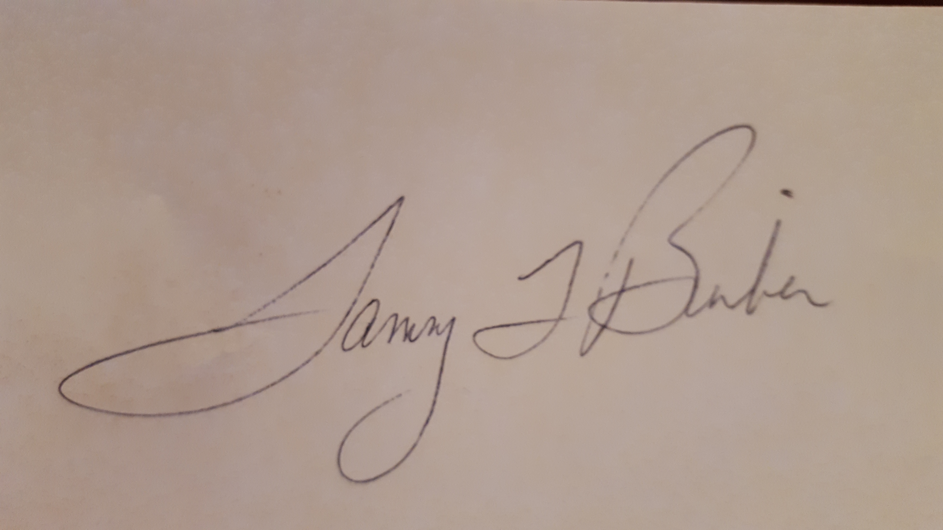

Typed Name: Stacy Robertson Typed Name: Tammy L Bimber

Date: Date: January 9, 2020

Title: Chief Financial Officer Title: Chapter President

